Bid proposal

In the second phase, PC members are required to bid the proposals. Each PC member must do a brief analysis of abstracts or papers to say if they are pleased to review some papers, or if they could evaluate some papers, or if they refuse to evaluate other papers.

The PC members must be registered in the conference with the role of chair or reviewer or both. Also, to bid a proposal, the PC members need to be logged in.

Step by step:

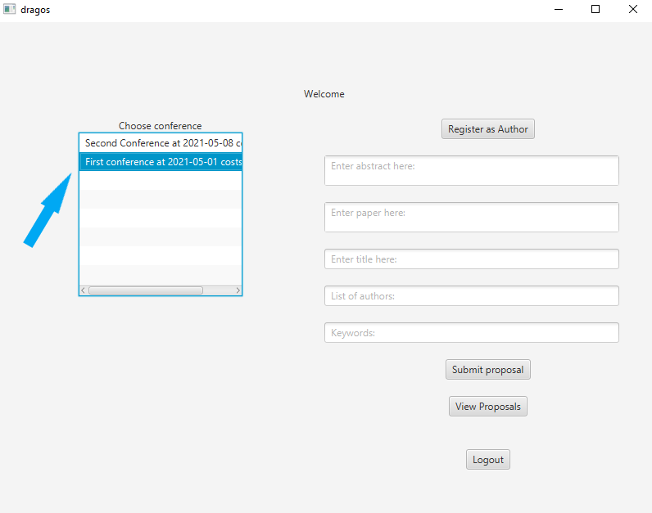1. Double click on the required conference

2. Double click on “REVIEWER” role

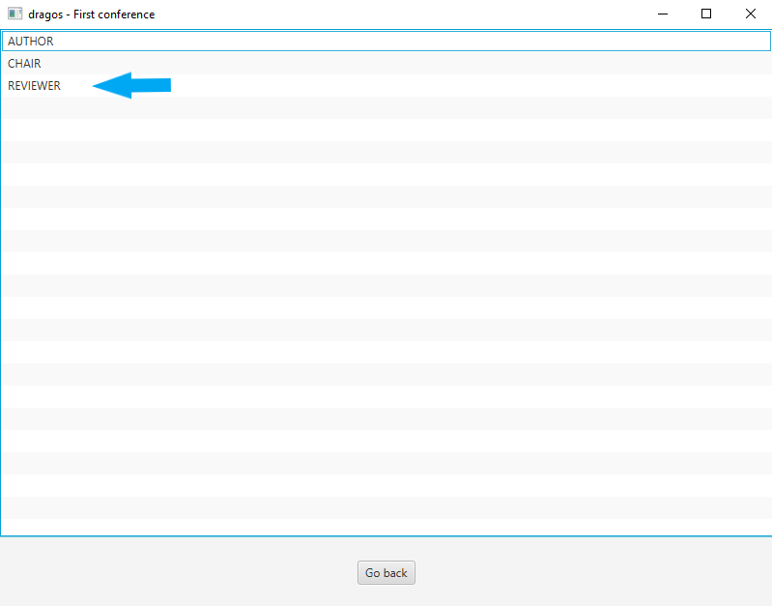

3. Click the “Bid proposal button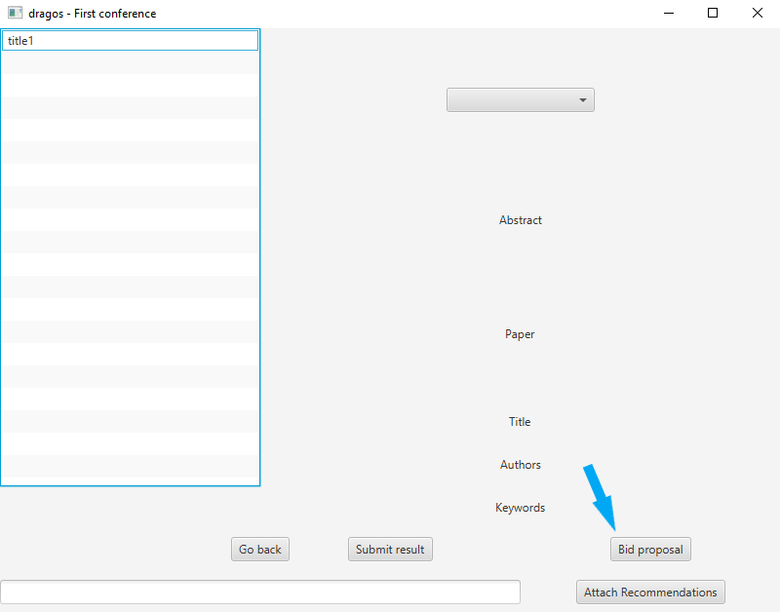

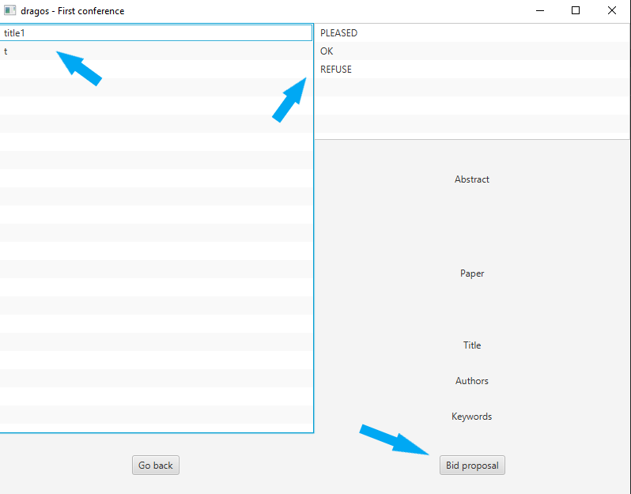

4. Click on paper

5. Click on acceptance level

6. Click on “Bid proposal” button

7. A notification with the status of the proposal will appear.

The operation will fail if:

- the paper is already bid

- a paper is not selected

- an acceptance level is not selected